

**Product Requirement Document**

**EV Charge Programming 2.0**

**Table of Contents**

1. Introduction介绍 4

1.1. Overview概述 4

1.2. Change log变更记录 5

1.3. Product General Information and Definition of Success产品简介和业务目标 6

1.4. Product Vision 产品愿景 8

1.5. Product Risks 产品风险 8

1.6. Assumptions & Remarks假设和备注 8

2. Product User Requirement使用者需求 8

2.1. Target Customer 目标客户 8

2.2. Customer Needs/Wants Description用户需求描述 9

2.3. Use Cases Description场景描述 9

2.4. Priority Description优先级描述 9

3. Different Alternatives可选方案 11

4. Feature Requirement功能需求 11

4.1. Features Overview功能总览 11

4.2. Functions Description功能详情EV Charge Programming 12

4.2.1. Preferred Charge Times 12

4.2.2. Departure Time 17

4.2.3. Charging info display： 19

4.2.4. Charge level setting： 12

4.2.5. Notification：pending on global’s feedback 20

5. Product Impact 产品影响 21

6. Data Plan流量计划 21

7. BETA Testing Requirements测试需求（Optional） 22

8. Non-Function Requirements非功能性需求 23

9. Go-to-Market Requirements上线需求 25

10. Operation Plan运营计划 25

# Introduction介绍

## Overview概述

This PRD document is to clarify requirements to stakeholders for EV Charge Programming 2.0 including Charge Info Display, Charge Level Setting, Preferred Charge Times Optimization and Departure Time Enhancement, etc.

Checklist

|  |  |  |
| --- | --- | --- |
| Item | Key sub-item | EVCP 2.0 PRD |
| 介绍 / Introduction | 概述 Overview | √ |
|  | 变更记录 Charge Log | √ |
|  | 产品简介与业务目标  Product Brief and Definition of Success | √ |
|  | 产品风险 Product Risk | √ |
|  | 假设与备注 Assumptions & Remarks | √ |
| 使用者需求 / Product User Requirement | 目标客户 Target Customer | √ |
|  | 用户需求描述 Customer Needs/Wants Description | √ |
|  | 场景描述 Use Cases Description | √ |
|  | 优先级描述 Priority Description | √ |
| 可选方案 / Different Alternatives |  |  |
| 功能需求 / Feature Requirement |  | √ |
| 外部集成需求 / Integration Requirements (optional) |  | Chapter changed to Product Impact |
| 流量需求 / Data Plan (optional) |  |  |
| 测试需求 / BETA Testing Requirements |  | √ |
| 非功能性需求 / Non-Function Requirements |  | √ |
| 上线需求 / GTM Requirements |  | √ |
| 运营计划 / Operation Plan |  | √ |

## Change log变更记录

|  |  |  |  |  |
| --- | --- | --- | --- | --- |
| **Version** | **Author** | **Description** | **Affected Sections** | **Revision Date** |
| V1.0 | Yu Zhang/Leon Dong | Initial Version | All | 6/10/2022 |
| V1.1 | Yu Zhang | Update charge progress bar display | 4.2.3 | 7/14/2022 |
| V1.2 | Yu Zhang | Update based on TL’s feedback | 1.3  1.5  1.6  4.2.1  4.2.2  4.2.5 | 7/19/2022 |
| V1.3 | Yu Zhang | Remove location-relevant requirement from this PRD (will create a new 3.0 PRD for PCT-remove location) | All | 7/29/2022 |
| V1.4 | Yu Zhang/ Leon Dong | Update based on aligned BRD with Congcong | Marked in blue | 09/08/2022 |

## Product General Information and Definition of Success产品简介和业务目标

EV Charge Programming is based on the vehicle end, the most basic charging service for vehicles, and consists of basic charging functions such as Charge Info Display, Charge Level Setting, Preferred Charge Times Optimization and Departure Time Enhancement, etc.

We plan to offer some basic charging features to users to solve some customer complaints in EV Charge Programming 2.0.

**Product Operation Metrics**

* Departure Times
  + 关键指标：按时出发执行成功率（结合DCSP诊断工具，持续监测生产数据，在上线前和业务同时一起设定具体目标）
  + 观察指标：按时出发使用率、按时出发设置成功率、用户设置的出发时间&舒适度分布
  + CSI：上线后可以提升x%（具体值结合持续问卷调研和客诉反馈，在上线前和业务同事一起设定）
* Charge Level Setting
  + 关键指标：执行成功率 99.9%
  + 观察指标：用户设置的上限值分布
  + CSI：上线后可以提升x%（具体值结合持续问卷调研和客诉反馈，在上线前和业务同事一起设定）
* Charge Info Display
  + 关键指标：信息显示准确率 99%
  + CSI：上线后可以提升x%（具体值结合持续问卷调研和客诉反馈，在上线前和业务同事一起设定）

## Product Vision 产品愿景

To offer some basic charging features to users to solve some of the customer complaints by EV Charge Programming 2.0.

## Product Risks 产品风险

EV features’ change has global dependency, so it will affect the launch time in China.

## Assumptions & Remarks假设和备注

|  |  |
| --- | --- |
| 名词 | 解释 |
| PEPC | Programable Electric Pre-conditioning and Charging |
| EVCP | EV Charge Programming |
| PCT | Preferred Charge Times 预约充电 |

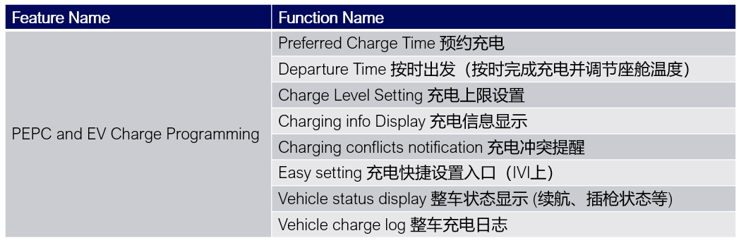

# Product User Requirement使用者需求

## Target Customer 目标客户

CX727, CX727 ICA, CX771, CX821 users

## Customer Needs/Wants Description用户需求描述

1. Departure time has a usage rate around 15%; Based on user feedbacks/complaints, Users want an easy-to-use feature rather than complicated logic

2. Customers want Charge level setting to control the target SOC for both AC & DC.

3. Customers want to know the real-time charging power when the vehicle is charging.

## Use Cases Description场景描述

Preferred Charge Times: Set a specific charging period to enjoy economic charging price.

Departure Time: Charge and precondition, let the vehicle ready to go at departure time.

Charge Level Setting: Set charge limit and can work on both AC and DC, with or without scheduled charging.

## Priority Description优先级描述

优先级标准：

高H: 有真实用户客诉，亟待解决或新增的功能，且目前无替代方案

中M: 暂无客诉，做了可提升用户体验，且目前无替代方案

低 L: 暂无客诉，做了可提升用户体验，但目前有替代方案

|  |  |  |  |  |  |  |
| --- | --- | --- | --- | --- | --- | --- |
| Feature Name | Function name | Sub-function | Upgrade/Keep | Priority | End | Remark |
| EV Charge Programming 2.0 | Charge level setting | Edit charge level | Upgrade | H | IVI&APP | 和竞品有差距，客户对该功能诉求多，需要尽快满足用户基本充电需求 |
| Charging Info Display | Display Charging speed & Charging power | Upgrade | H | IVI&APP&Cluster | 和竞品有差距，客户对该功能诉求多，需要尽快满足用户基本充电需求 |
| Charging progress bar display | Upgrade | M | IVI&APP | 将复杂的显示逻辑做简化 |
| Preferred  Charge Times | Charge Limit | Upgrade | H | IVI&APP | 用户不满足当前仅AC预约充电里的Charge Limit设置，有客诉。属于高优先级，需要和charge level setting合并。 |
| Toggle (Mutually exclusive with Departure Time) | Upgrade | M | IVI&APP | 简化，和按时出发开关不能同时打开 |
| ~~One-Time Charge now~~  ~~本次立即充电~~ | ~~Upgrade~~ | ~~L~~ | ~~APP~~ | Move to EVCP 3.0 |
| Remove Charge Times | Keep | - | IVI&APP | - |
| Save, Remove, Edit Locations | Keep | - | IVI&APP | - |
| Add & Edit Change Times | Keep | - | IVI&APP | - |
| Departure Time | Add & Edit Departure Time | Upgrade | M | IVI&APP | 功能使用率低，但是收到一些用户反馈，说功能复杂，需要优化UE/UI； |
| Toggle (Mutually exclusive with PCT) | Upgrade | M | IVI&APP | 功能使用率低，但是收到一些用户反馈，说功能复杂，需要优化UE/UI； |
| Preconditioning | Keep | - | IVI&APP | - |
| Notification | See 4.2.5 | Upgrade | M | IVI&APP | Pending for global |

# Different Alternatives可选方案

None.

# Feature Requirement功能需求

## Features Overview功能总览

**771/821 UE Example**

1. 点击launcher页充电卡片

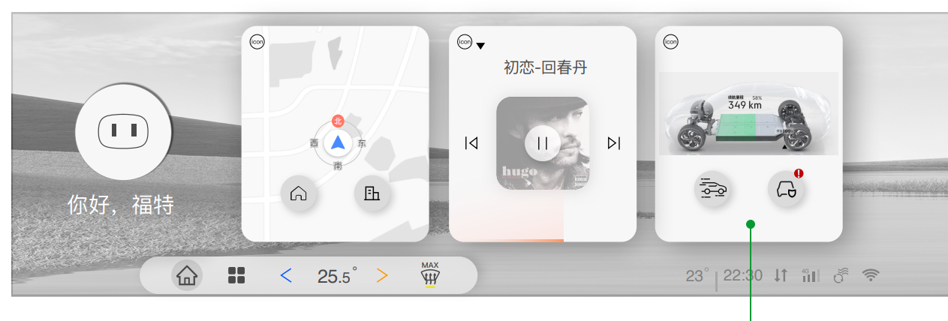

1. 进入充电设置页

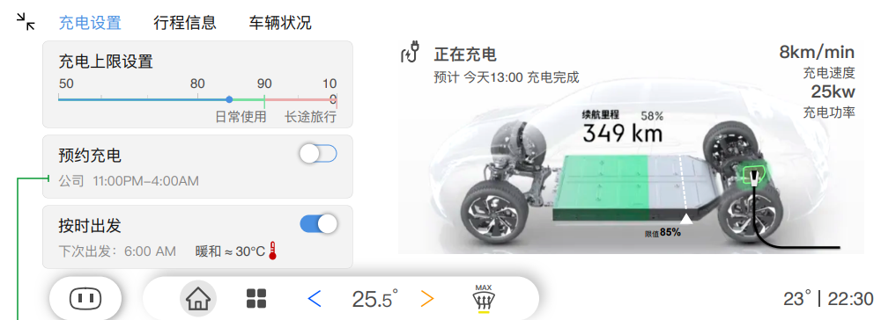

**Feature Priority Description-**

**Charge Level Setting & Preferred Charge Times & Departure Time**

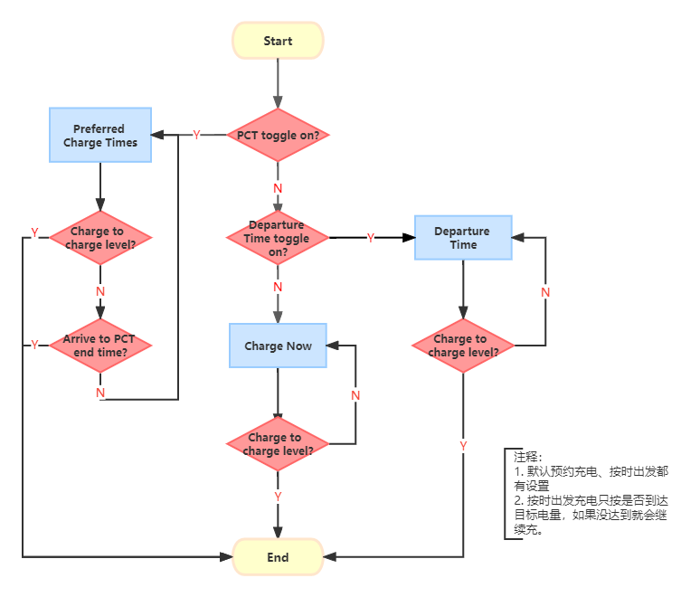

**P-1** EVCP 2.0 Features Flow

## Functions Description功能详情EV Charge Programming

### Charge level setting：

#### 界面原型 Prototype：

User Journey:

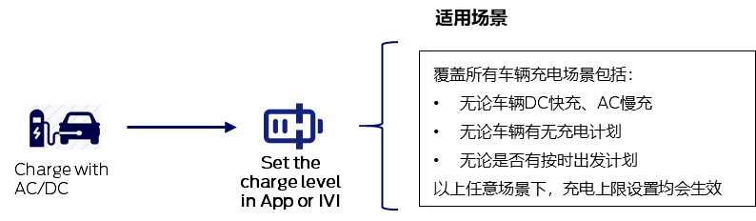

UE example:

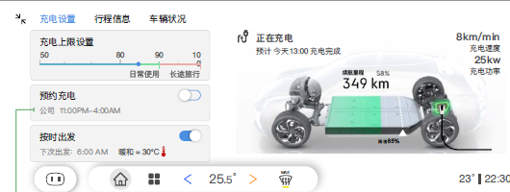

#### 业务规则描述 Description:

* **Add universal charging limit SOC (for both AC and DC at any location）**
* **For prefer charge time: PCT leverages Charge Level Setting feature to control the charge limit of PCT. Once Charge level setting is set, PCT cannot charge over the setting. （See 4.1 P-1）**
* **For Departure time: Leverage charge level setting to control target SOC; (See 4.1 P-1 user case)**
  + - If reaches to target SOC before departure time, the vehicle will stop charging.
    - If the vehicle does not meet target SOC when departure time arrives, the car will continue charging to charge level.
* **Update the logic of estimated charging completion time, display the time of charge to the target soc（The information in Cluster & IVI & App）**（See 4.2.2.2）**.**
* **Tracking data: Distribution of user set limit value**

### Charging info display：

#### 界面原型 Prototype：



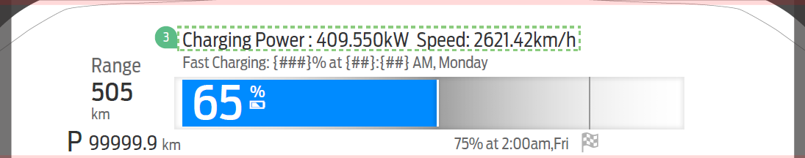

80%

#### 业务规则描述 Description:

**Display the charging power（kw）& charging speed（km/min）:**

Scenario：

|  |  |  |  |  |  |
| --- | --- | --- | --- | --- | --- |
| **车辆插枪状态** | **车辆上电（车辆已启动 not ready to go）** | **车辆正在充电** | **Cluster** | **IVI** | **App** |
| **Y** | **Y** | **N** | **显示当前充电状态进度条，如等待充电（预计xx：xx开始充电）/充电已完成/充电异常等** | | |
| **Y** | **Y** | **Y** | **显示当前充电状态进度条，如正在充电（预计xx：xx充电完成-DC充电时，当目标电量＞80%，额外显示充至80%时间） +充电功率+充电速度/充电异常等** | | **显示当前充电状态进度条，如正在充电（预计xx：xx充电完成-DC充电时，当目标电量＞80%，额外显示充至80%时间）/充电异常等** |
| **Y** | **N** | **N** | **黑屏状态，无信息显示** | | **显示当前充电状态进度条，如等待充电（预计xx：xx开始充电）/充电已完成/充电异常等** |
| **Y** | **N** | **Y** | **黑屏状态，无信息显示** | | **显示当前充电状态进度条，如正在充电（预计xx：xx充电完成-DC充电时，当目标电量＞80%，额外显示充至80%时间）/充电异常等** |
| **N** | **Y** | **-** | **无充电状态相关信息显示** | | |
| **N** | **N** | **-** | **无充电状态相关信息显示** | | |

### Preferred Charge Times

#### Prototype

2.0: Remove charge limit from PCT setting process.

User Journey:

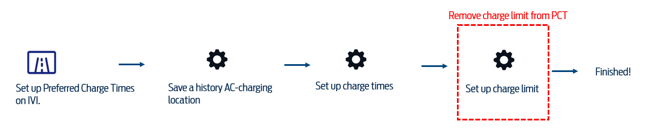

771/821 UE example:

1. 编辑预约充电，点击添加新计划

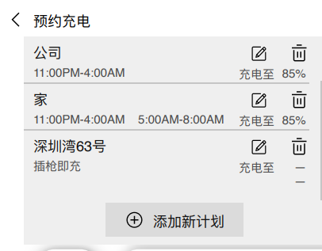

1. 编辑位置，编辑充电时间段

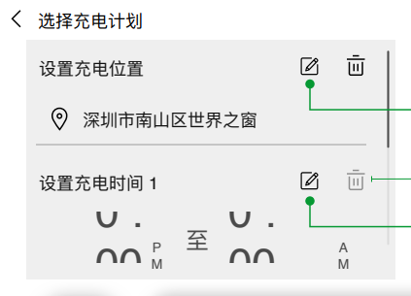

1. 点击左上角返回，完成设置

#### 业务规则描述Description

**Preferred Charge Times is for AC charging only: If the vehicle is on DC Charging, user will not be able to use Preferred Charge Times.**

1. **~~Charge Now~~ Requirement Move to 3.0**

**~~Add Charge Now, which is a one-time feature that allows the users to skip preferred time for one time when they want the vehicle to charge right away, but this action will not change or override overall PCT plan.~~**

* 1. ~~If PCT is on, click charge now on APP, the vehicle will start charging immediately to charge level; When charge ends, Charge now will be closed, and the PCT is still on schedule, and the vehicle will charge by scheduled plan next time.~~
  2. ~~A notification is needed when charge now updated failed from APP to vehicle.~~

1. **Add & Edit Charge Times**

此处逻辑没变，后续会补充流程图和UE进来。

1. **Remove Charge Times**

此处逻辑没变，后续会补充UE进来。

1. **Charge Limit**

**Remove charge limit from PCT setting process; PCT will leverage Charge Level Setting feature to control the charge limit. Once Charge level setting is set, PCT cannot charge over the setting. (See 4.1 P-1)**

* 1. Based on HPCM calculation, if PCT charge period is less than actual time needed, the vehicle will charge in advance (before the PCT start charge time).
  2. If the charge level is reached within the preset charging period, vehicle will stop charging. A notification to user will be triggered.
  3. If the limit is not reached by charge time ends, a notification will send, and the vehicle will still stop charging according to HPCM calculation.

1. **Save, Remove, Edit Location**

**Keep location based PCT for 2.0. Users need to save an AC charging location firstly to set up a Preferred charge time.**

此处逻辑没变，后续会补充流程图

1. **Toggle: Can control the on & off of PCT**

Preferred Charge Times and Departure Time cannot both be switched on; Users need to choose Preferred Charge Times or Departure Time to use.

* 1. A pop-up will be triggered when users switched on one feature and still try to open the other feature:

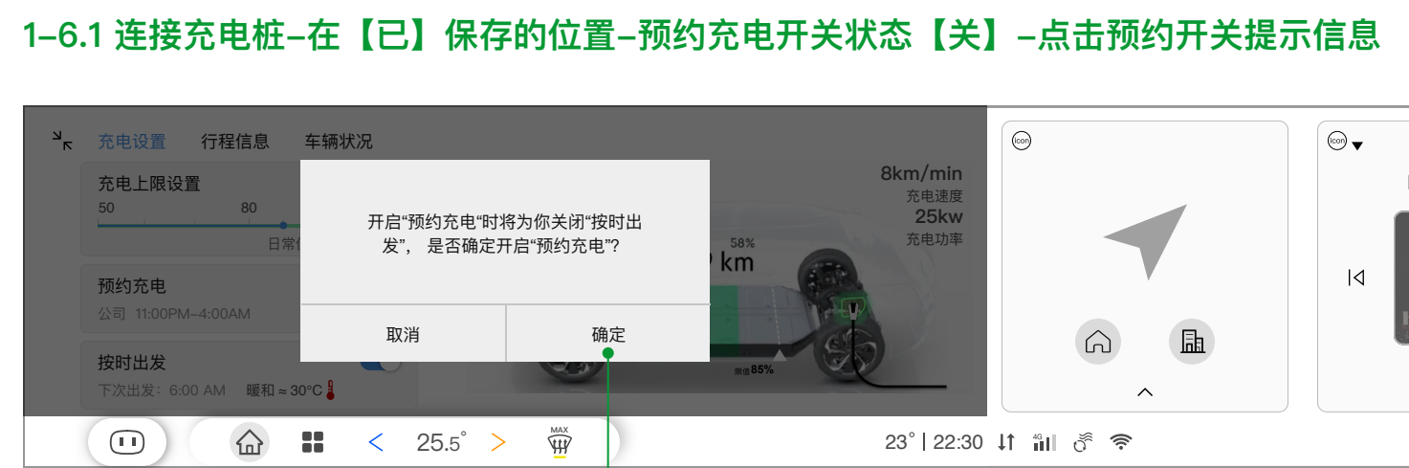

* 当前场景是预约充电打开，按时出发关闭：点击按时出发开关，跳出弹窗，点击确定，则预约充电自动关闭，按时出发自动打开
* 当前场景是按时出发打开，预约充电关闭：点击预约充电开关，跳出弹窗，点击确定，则按时出发自动关闭，预约充电自动打开

1. **APP- Preferred Charge Times change**
   1. Cloud signal change is needed
   2. APP UX/UI re-design based on 2.0 enhancement is needed

### Departure Time

#### 界面原型Prototype：

2.0 User Journey:

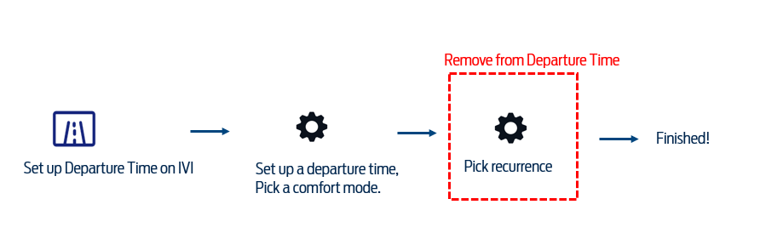

2.0 UE Change:

1. 编辑按时出发，或者新建计划

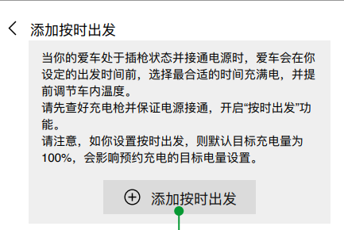

2. 编辑出发时间和温度模式

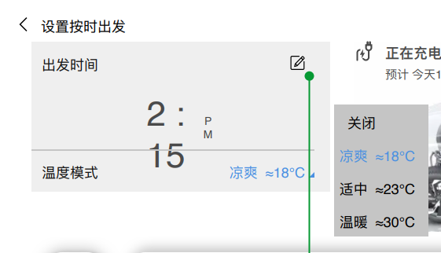

3. 点击返回完成设置

#### 业务规则描述Description

**The charging function of departure time can work on AC, but the preconditioning of departure time can work both on AC and DC.**

**Vehicle needs to be plugged in to use Departure Time. The power for preconditioning is not from vehicle HV battery but from outside grid when plugged in. If not plugged in, the vehicle will not precondition.**

1. **Add & Edit Departure Time**

Reduce to 1 recurring departure time event (and its preconditioning setting) rather than 14 Times (14 for 7 days)

a. Recurring: Users only need to set a departure time and pick a comfort mode and setting finished. The setting will keep unless the user wants to edit.

b. If the user needs a change of departure time and comfort mode, they can edit this one setting.

1. **Preconditioning**

There are 4 modes to choose for the air conditioning: Cold, Warm, Hot and Closed.

Preconditioning (including cabin conditioning and battery conditioning) will start 15min before the departure time and stop 15 min after the selected time if the vehicle is not started/ignited.

If battery temperature is below 10c when plugged in, it will calculate the time needed to condition the battery and start conditioning prior to cabin conditioning. Battery conditioning will continue until battery temperature reached to 15c.

Priorities and Conflicts with Remote Climate Control

* RCC 先开启且未结束，按时出发 (Departure Time) 的空调 (Cabin conditioning) 能不能再继续开始执行？Pending global’ s feedback
* 按时出发空调已开启，app端能不能看到远程状态(启动按键显示为熄火)？Pending global’ s feedback
* 按时出发空调和RCC toggle是否开启的关系是什么？Pending global’ s feedback
* 按时出发空调已开启，此时如果修改RCC的设置页面内的空调、方向盘、座椅，是否能实时生效？Pending global’ s feedback
* 按时出发空调已开启，点熄火按键是否会关闭空调设置？Pending global’ s feedback
* 按时出发空调已开启，RCC设置页面关闭空调不能实时生效. Pending global’ s feedback

1. **Toggle**

Cannot switch on while Preferred Charge Times is on.

1. A pop-up will be triggered when users switched on one feature and still try to open the other feature:



* 预约充电打开，按时出发关闭：点击按时出发开关，跳出弹窗，点击确定，则预约充电自动关闭，按时出发自动打开
* 按时出发打开，预约充电关闭：点击预约充电开关，跳出弹窗，点击确定，则按时出发自动关闭，预约充电自动打开

1. **Leverage charge level setting to control target SOC; (See 4.1 P-1 feature flow)**
2. If reaches to target SOC before departure time, the vehicle will stop charging.
3. If the vehicle does not meet target SOC when departure time arrives, the car will continue charging to charge level.（See 4.1 P-1）
4. **APP- Preferred Charge Times change**
   1. Cloud signal change is needed
   2. APP UX/UI re-design based on 2.0 enhancement is needed

### Notification：pending on global` s feedback

**Notification Form: Enhancement is marked in yellow; Removal is marked in gray.**

|  |  |  |  |  |  |
| --- | --- | --- | --- | --- | --- |
| **Notification业务场景** | **站内信 In-app Message** | **推送 App Push Notification** | **短信 SMS** | **Message Trigger Expire Date** | **Remark** |
| 充电达到单次充电阈值提醒 | Y | - |  | 1 day | To update，Add DC charging scenario  根据您的充电设置，{vehicleNickname}已经充电至{ChrgToPcWkdySav_D_Stat}%。请放心驾驶！ |
| 非主动停止充电时推送提醒 | Y | Y | Y | 1 day | Keep |
| 在保存的位置充至预期电量提醒 | Y | Y |  |  | Keep |
| 快充充至80%电量提醒 | Y | Y |  |  | Keep |
| 按时出发同步失败 | Y | Y |  |  | Keep |
| 预约充电同步失败 | Y | Y |  |  | Keep |
| 无法充至预期电量 Conflict Notification | Y | Y |  |  | keep |
| 车辆充电故障 | Y | Y |  |  | Keep |
| 意外断开连接 | Y | Y |  |  | Keep |
| 车内温度调节就绪提醒 | Y | Y |  |  | Keep |
| 在未保存的位置充至100%电量提醒 | Y | Y |  |  | To remove |
| 预约充电未开始提醒 | Y | Y |  |  | To remove |
| 插枪提醒（有预约充电的情况下） | Y | Y |  |  | To remove |
| 预约充电同步完成 | - | - |  |  | To remove |
| 预约时间段外充电 | Y | Y |  |  | To remove |

*将所有文案的出发时间改成按时出发；

# Product Impact 产品影响

EVCP 2.0 enhancement needs to be discussed with the following teams-

Voice AI Team: to discuss; 输出需求，新增进入车辆充电上限设置指令、修改预约充电、按时出发部分指令。

E-manual Team: to discuss；输出需求，修改EVCP相关功能介绍。

# Data Plan流量计划

暂不提供

# BETA Testing Requirements测试需求（Optional）

EV Charge Programming需要功能性测试，由E2E团队负责测试。

PO会进行UAT产品验收。

根据实际情况规划user validation

# Non-Function Requirements非功能性需求

性能指标（时延、并发量等）、法务需求、安全性需求、埋点需求（产品埋点如何规划的，拿到数据后看哪些信息）

**EVCP 2.0 has no legal risk, concurred with legal team.**

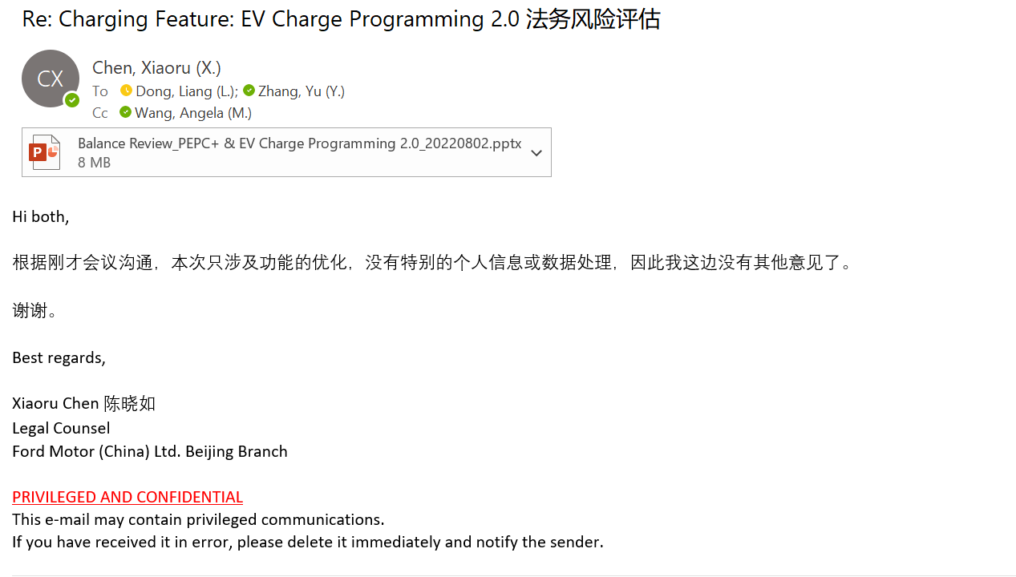

Tagging (Refer to Backlog Charging-Data Analysis )

* APP tagging (神策)：规划出UE后，设计前端埋点。
* IVI tagging (Digital EE) ：会根据现有UE评估大概的埋点工作量提供给Operation团队，后续等UE确认，我们再设计具体埋点，并自行和Digital EE团队沟通。
* DCSP Data Analysis：功能上线前，根据指标，更新需求给DCSP获取后台数据。

# Go-to-Market Requirements上线需求

功能上线前GTM team需要安排功能宣传。

# Operation Plan运营计划

业务运营会和BO合作, 届时BO会安排微信推文、APP社区帖子来发布教育贴。